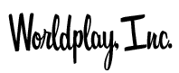
presents

See What I’m Saying:

The Deaf Entertainers Documentary
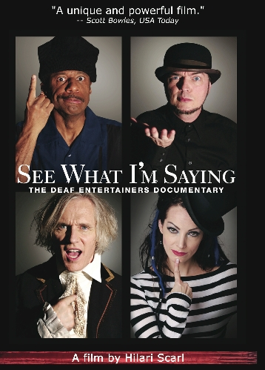
(USA 2010, 90 minutes, rated PG-13)

SEE WHAT I'M SAYING: THE DEAF ENTERTAINERS DOCUMENTARY
Hilari Scarl
Director/Producer
SEE WHAT I'M SAYING
The Deaf Entertainers Documentary
www.SeeWhatImSayingMovie.com
Hilari@WorldplayInc.com
cell (310) 467-5054
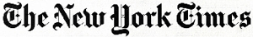

New York Times - CRITIC’S PICK
“Complex, candid and all-but-essential viewing for hearing audiences, Hilari Scarl’s intrepid debut feature, ‘See What I’m Saying: The Deaf Entertainers Documentary,’ educates without lecturing and engages without effort.” - Jeannette Catsoulis

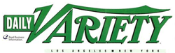

“An outstanding documentary exploration of the travails of four deaf entertainers, Hilari Scarl's "See What I'm Saying" provides a glimpse into a performance circuit that few hearing-enabled Americans likely realize exists. Rather than a disability, deafness begins to seem almost an entry fee into a singular subculture with celebrities, traditions and prejudices all its own, and this community's actors and artists face troubles that are both familiar and fascinatingly strange. Well-made docu should have little difficulty finding a receptive audience at fests and on homevid.” - Andrew Barker



"You have not seen a movie like 'See What I'm Saying.' Hilari Scarl's powerful and moving film about the unsung community of deaf entertainers does something few documentaries accomplish: It takes us into a world we know little or nothing about and not only enlightens, but entertains. Scarl has captured the humor, heartbreak and pathos of a world we once viewed only from the outside, if at all.” – Scott Bowles, USA Today



“…a significant look at a vital, underreported segment of the entertainment world.”

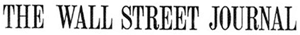

“See What I’m Saying lets images do the talking.”



“This new film about deaf entertainers looks like something I must see.”
Robert Ebert of the Chicago Sun Times via Twitter

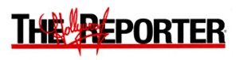
“See what I’m Saying documentary a sign for deaf entertainers.”



"All-inclusive"

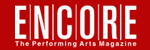

"In truth, this unique documentary is not meant to be read about. This preview will not pretend to do it justice. See What I'm Saying: The Deaf Entertainers Documentary is meant to be seen, for both hearing and deaf audiences. From it, one will learn you do not need to be able to hear to listen to the truth. So, start listening." - Andrew Hall



"Hilari Scarl sees what we're saying..."

FESTIVAL ACCOLADES

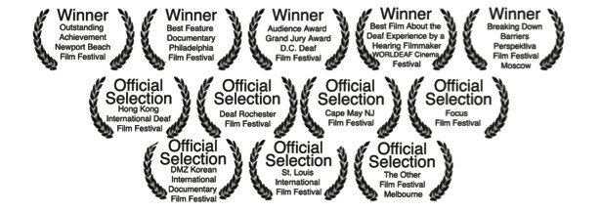

Philadelphia Film Festival
Winner - Best Feature Documentary

AFI – VSA International Disability Film Festival
Opening Night Film (June 7, 2010)

Newport Beach Film Festival
Winner - Outstanding Achievement in Documentary Filmmaking

WORLDEAF Cinema Festival
Winner - Best Film about the Deaf Experience by a Hearing Filmmaker

Perspektiva Film Festival – Moscow
Winner – Breaking Down Barriers

D.C. ASL Film Festival
Grand Jury Award

D.C. ASL Film Festival
Audience Award

St. Louis Film Festival
Official Selection (sneak preview test screening)

Hong Kong International Deaf Film Festival
Official Selection

The Other Film Festival – Australia
Official Selection

DMZ Film Festival - Korea
Official Selection

CHARACTERS BIOS

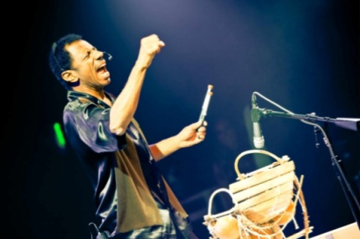
CJ Jones, A Deaf Icon

CJ Jones is a superstar -- a deaf comic recognized and celebrated around the world by the deaf community, yet he struggles to gain access in mainstream media. CJ strives to cross over to hearing audiences, but plagued by what others view as a “double whammy,” being black and deaf, CJ’s journey takes a unique turn when he decides to take his performing destiny into his own hands and produce the first International Sign Language Theatre Festival in Los Angeles. Once in motion, CJ invites Robert DeMayo to perform.

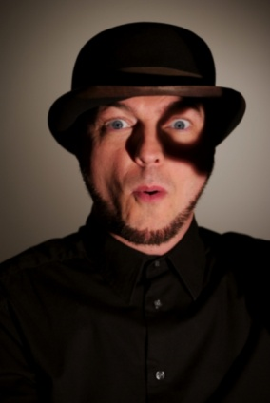
Robert DeMayo, actor

The extraordinarily talented and optimistic Robert DeMayo is a brilliant actor and one of the leading experts on translating English into American Sign Language. He is also homeless and HIV positive. While teaching sign language translation to Broadway interpreters at Juilliard, lack of steady work leads him down a slippery slope of couch surfing and ultimately onto the Philadelphia city streets where he fights to survive.

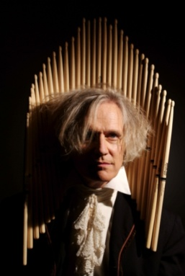
Bob Hiltermann, drummer

Beethoven’s Nightmare, the world’s only deaf rock band, gears up for the most important gig of their lives: their first mainstream show. Bob Hiltermann, the band’s drummer/producer decides to follow his life’s passion, go for broke, and produce the largest concert in the band’s 30-year history.

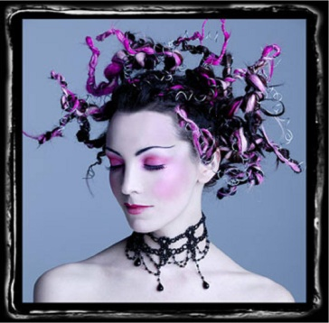
TL Forsberg, singer

In your face rocker TL Forsberg, straddles two worlds – the deaf and the hearing. As a hard of hearing singer, she struggles to be accepted by the deaf community since she is not a native sign language user and “passes” in the hearing world. Her passion leads her to a recording deal to produce her first CD entitled “Not Deaf Enough,” but things take a surprising twist when she opens for Bob's deaf rock band, Beethoven's Nightmare.

SEE WHAT I'M SAYING: THE DEAF ENTERTAINERS DOCUMENTARY
A Film by Hilari Scarl

SYNOPSIS

This inspirational and heartfelt documentary follows four well-known entertainers in the deaf community: a comic, a drummer, an actor and a singer as they attempt to cross over to mainstream audiences. These uniquely talented deaf entertainers overcome great challenges on their way to personal triumphs and professional success.

Bob, a drummer in the world’s only deaf rock band, Beethoven’s Nightmare, produces the largest show in the band’s 30 year history; CJ, a hugely famous and internationally renowned comic in the Deaf world, but virtually unknown to hearing audiences, fights to cross over to the mainstream by producing the first international sign language theatre festival in Los Angeles; Robert, a brilliant actor who teaches at Juilliard, struggles to survive when he becomes homeless while living with HIV; and TL, a hard of hearing singer finds herself caught between the hearing and deaf communities when she attracts her first major producer to record her first CD “Not Deaf Enough.”

Chronicled with rare intimacy and candor, SEE WHAT I’M SAYING: THE DEAF ENTERTAINERS DOCUMENTARY is the first open captioned* commercial film in American history. At the same time, it opens the door to deaf culture, allowing the sign language in the film to be accessible to all audiences. With humor and emotion, director Hilari Scarl captures with insight and honesty the many obstacles these performers face daily.

*OPEN CAPTIONS – DEFINITION
The term “Open Captions” is used when text is burned-in on the picture, similar to subtitles for foreign films. Open captions also includes audio descriptors and non-speech information that assist deaf audiences, such as [phone rings] or a musical note symbol to indicate song lyrics or background music. Open captions are part of the film and can’t be turned off, unlike closed captions which can be turned on and off with a decoder. Captions for SEE WHAT I’M SAYING were generously funded by Microsoft.

DISTRIBUTION
SEE WHAT I’M SAYING is being self distributed by Worldplay, Inc. and has screened in over 50 cities through bookings in both mainstream movie theaters and bookings from Universities, deaf events and various organizations. The film has screened in over 100 cities around the world. The DVD and digital rights are being distributed by New Video.

ANCILLARY AVAILABLE

- SEE WHAT I’M SAYING – DVD for home personal use.

- SEE WHAT I’M SAYING – DVD screening package for theatrical, educational and fundraising events.

- ME HEAR NONE: Additional Performances from See What I’m Saying 96-minute DVD of full live performances featuring Robert DeMayo, Max Fomitchev, the Russian Deaf Theater company from CJ’s International Sign Language Theater Festival plus new performances. Fully captioned in English.

- Educational DVD package – supplemental scenes and teacher workbook.

- Limited edition autographed poster (signed by all four subjects plus director.)

- Movie poster (unsigned) – 24” x 36” high gloss paper.

- Poster Card – 11” x 17” high gloss 10 pt card.

- Postcards – 6” x 4” with movie poster on front, film details on the back.

- T-shirts and collectibles.

SPONSORS

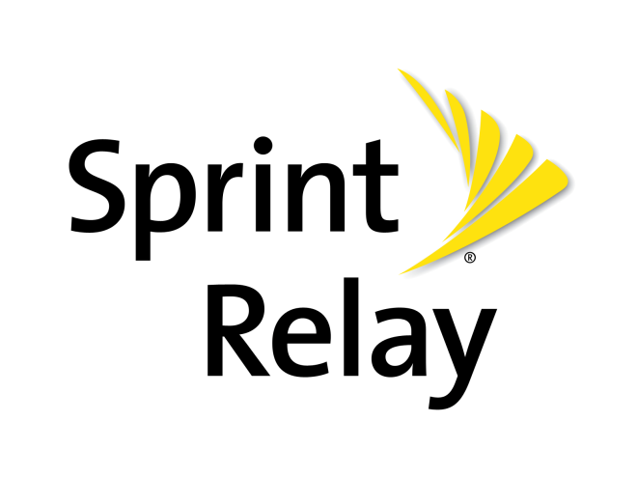

SEE WHAT I’M SAYING has partnered with Sprint Relay, a division of Sprint that caters to deaf and hard of hearing users. Sprint enlisted the film’s production company Worldplay, Inc. to produce a music video of the film’s title song, SEE WHAT I’M SAYING that runs before the film during the 25-city tour. The video was featured at the red-carpet world premiere in Los Angeles on March 18, 2010 at the Egyptian Theater followed by the East coast premiere in New York City on April 9, 2010 at the Village East Cinema.

The film’s barnstorming tour celebrates the first open captioned commercial film in American history, making it accessible to more than 30 million deaf and hard of hearing Americans.

The scheduled 25-city tour recently expanded to include many more mainstream theaters, allowing the film to reach many more deaf and mainstream audiences across the country. This creative partnership with Sprint, will bring national attention to Sprint’s Video Relay Service and upcoming 4G network, allowing deaf and hard of hearing users equal access to communication through video relay interpreters, CapTel and WebCapTel services.

SEE WHAT I'M SAYING: THE DEAF ENTERTAINERS DOCUMENTARY
A Film by Hilari Scarl

FILMMAKERS STATEMENT

My first introduction to Deaf culture was a performance at New York Deaf Theatre of “’Night, Mother” with Freda Norman that changed my life. Having been in theatre my entire life and experiencing almost every form of theatre from Kabuki to Shakespeare, I had never seen anything like this visual and highly emotional art form. The performances came to life with a visceral impact that was visually and emotionally powerful, simultaneously translated by unseen voicing actors. I was hooked.

After taking a few sign language classes and living with a Deaf roommate in New York, I auditioned for the Tony-award winning National Theatre of the Deaf (NTD) and was cast as a voicing actor. I toured for a year with some of the most extraordinarily talented performers I had, ever known.

The cast included Anthony Natale who was cast that year in “Mr. Holland’s Opus,” Frank Dattolo who went on to become the artistic director of New York Deaf Theatre, and Robert DeMayo, who became one of the lead subjects of SEE WHAT I’M SAYING. My total immersion into Deaf culture wasn’t easy. I was a minority on a tour with 17 Deaf actors who lived in a world with a unique bond I could not share.

I was tested in numerous ways. Trust was slowly built as we transformed from peers into friends. After a year of sharing their lives and their world, I was accepted as part of the ensemble’s unique family. Watching the blistering gap between my newfound friends and the hearing world in our everyday interactions, I witnessed indifference to them in public. Their stories inspired me to do better. At the end of the tour, I moved to Los Angeles with the desire to tell their story to the hearing world. I wanted others to see these talented actors as I saw them, and for audiences to meet my friends whom I had grown to love.

THE DIRECTOR’S MESSAGE & GOALS
- I want audiences to see that Deaf culture is vibrantly rich and filled with brilliant, creative, intelligent and inspiring human beings who share the same dreams and aspirations as everyone else.

- I hope to inspire Hollywood to cast actors who happen to be deaf rather than thinking they have to have a deaf storyline in order to cast a deaf actor. Just like any other minority actor, deaf actors can play virtually any role. I hope this film creates more opportunities for deaf performers everywhere.

I hope that SEE WHAT I’M SAYING shows the importance of captions and encourages more producers to caption their films, internet clips, trailers and other media to make it accessible. I hope to create awareness regarding the need for quality captions in all media – film, television and the internet. We take for granted the accessibility that captions provide, and the need is grossly underestimated.
PRE-PRODUCTION
In 2007, I was chosen by Steven Spielberg out of 12,000 filmmakers to be on his television show and had my 15 minutes of fame ON THE LOT. After making it to the top 21, I asked everyone who was going to vote for me 20 times to send me $20 to make this documentary. I managed to raise $8,000 over a single summer to begin filming. Luckily, several supportive investors came on board during production and post production, as well as a grant from the Arnold Glassman Fund and sponsorship from Microsoft and Sprint. Since I knew I wanted the film to be as verité as possible with a strong story, I checked in with a dozen of my friends and colleagues to see who had events planned for the year. I had met CJ Jones when I first arrived in Los Angeles and we became close friends. I knew he was planning some large events that would be unique to follow. To know CJ is to love him, and it was time for the rest of the world to know him as well. CJ introduced me to TL during a performance and I was instantly intrigued by her story. And when Bob told me he was planning the largest Beethoven’s Nightmare show in 30 years, I knew I had a great arc to follow. [SPOILER ALERT.] I found out that Robert was homeless, sleeping on park benches in Philadelphia days before he was scheduled to leave for New York to teach at Juilliard, and I immediately grabbed a camera and flew on a kind friend’s frequent flyer miles out to Philadelphia to find out what was going on. Robert’s story blew me away and I knew I had to film it.

I never had a casting session; I chose entertainers with high stake events happening in 2007. I hope the film brings home the point that there are dozens of other extremely talented unsung deaf entertainers. I followed a few other extraordinary entertainers during our filming including Kathy Buckley, Michelle Banks, Howie Seago, Tyrone Giordano and Anthony Natale whom I hope to feature in our DVD extras.

PRODUCTION
Filming was extremely challenging. As we followed our busy entertainers, we ended up filming over 50 deaf entertainers in over 12 cities throughout the United States and overseas. Invitations to perform, auditions and life-altering situations kept arising, keeping us scrambling and booking two and sometimes three different crews at a time. But the perks of filming in sign language were unique as well. I could hold interviews in noisy places and dump my audio (which happened at least twice) since the film is captioned. People didn’t ask us to move along since they couldn’t figure out what we were doing. The best perk was being able to interject questions in sign language without blowing a sound bite.

POST PRODUCTION
Our post production was unique, since to our knowledge nothing like this had ever been done before. Three different interpreters rotated in and out of the editing bay laying down temporary audio voice over for my hearing editor as I transcribed over 700 pages of 300 hours of footage. It took six months of working nearly 80 hours a week to produce four complete storylines for each of our major subjects, and another three months to weave the stories together. Our temp interpreter audio track was replaced by subtitles that took weeks to fine tune by ASL Master James Foster during the formal translation process. The film then went through another nine months of test screenings, focus groups with audience discussions and editing full time to finish the film.

The score and the sound design were incredibly fun, as my longtime composer Kubilay Üner wrote a beautifully inspired score. Joe Milner, our post production sound supervisor, quizzed Robert meticulously to accurately depict how things sound from his point of view. Our publicity photo shoot by celebrity photographer Chris Voelker (who just happens to be a wheelchair user) ended up as our epilogue in the film. During the photo shoot, Robert DeMayo came up with the signed translation for SEE WHAT I’M SAYING that was seconded by CJ Jones. The literal translation of our poster in sign language is “understand what I’m saying” and the play on the word “see” (“understand what I’m saying” and to visually see the language) is meant to be a double entendre only in English.

TOURING WITH THE FILM
Screening the film in front of hundreds of audiences over the first few months was one of the most rewarding events of my life. A few highlights:

- A young deaf girl from an entirely hearing family was so isolated that her church took the entire community to the screening to do “something nice for her.” They didn’t realize that the film would hit them so hard and open their eyes. Her family, pastor and neighbors decided to begin sign language classes the following week.

- Our opening day in Los Angeles, a group of deaf bikers drove in from Arizona to be first in line for the first screening. Hundreds of other fans came in from across California as far away as San Francisco, Santa Barbara and San Diego; others drove from Mexico, Oregon and Washington DC to see the film opening week.

- A group of deaf high school students had never seen a film in a movie theater before in their life and gave the film a 2-minute standing ovation.

- Hundreds of hearing people who had never met a deaf person have left the theater profoundly changed, having been introduced to a world they never knew existed. Many have written me emails letting me know that they are now inspired to start learning sign language and get more involved with the deaf community.

- Dozens of people with hearing loss have stood up at multiple screenings saying they have never seen someone like themselves represented in mainstream media before, saying that TL has given them validation for the first time in their lives.

- Deaf icons Bernard Bragg, Tyrone Giordano, Shoshannah Stern, John Maucere and others have cheered the film on from the beginning and were at the red carpet world premiere in Hollywood, which was filmed by both deaf and hearing media.

- CJ Jones’ oldest daughter Sunny saw the film for the first time during a screening in St. Louis and burst into tears during the Q&A, saying that this was the film she has been waiting for her entire life for her dad to finally get the recognition he deserves.

- Ron Meyer, President/COO at Universal Studios saw the film and personally called to say how much he loved SEE WHAT I’M SAYING.

- DreamWorks booked the film to be screened for their employees. It was enthusiastically received along with a Q&A with director Hilari Scarl and DreamWorks editor Marcus Taylor.
SEE WHAT I'M SAYING: THE DEAF ENTERTAINERS DOCUMENTARY
A Film by Hilari Scarl

CREW BIOS

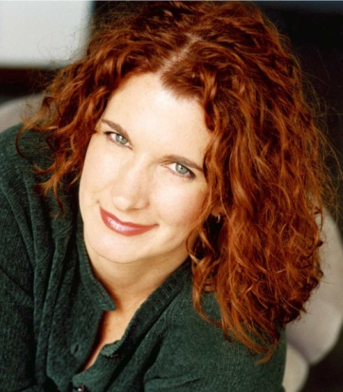
Hilari Scarl, Director/Producer

Hilari is an award-winning director who was selected out of 12,000 filmmakers to appear on the Steven Spielberg television series ON THE LOT. She received outstanding reviews from judges Garry Marshall, Carrie Fisher, Jon Avnet and Brett Ratner on her short comedy DITTO and for her cinematic vision and overall strength in working with actors.

Hilari has produced TV shows for CBS, The History Channel, TLC and Court TV. She directed/produced over 12 short films in two years, including the short documentary PAVING THE WAY which was a finalist for International Documentary Challenge, played the film festival circuit and was acquired by Current TV. Her narrative short SNIPS & SNAILS is a horror spoof that she directed, co-wrote and co-produced with Gary Anthony Williams. The film has won awards and screened at film festivals around the world.

Hilari’s interest in the deaf community began in 1992 when she started working in deaf theatre. She has spent the past 18 years working with the deaf community as a director, performer and educator with the Tony Award-winning National Theatre of the Deaf (NTD), the Deaf Arts Council, New York Deaf Theatre and Deaf West. She brings her intimate knowledge of deaf culture, personal friendships within the deaf community and signing skills to this documentary. After directing/producing 18 short films (15 of which won awards/received distribution), this is Hilari’s first feature film.

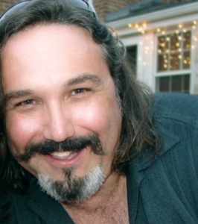
Jeff Gatesman, Cinematographer

Originally from Chicago, Jeff received a degree in journalism at Triton College where he was introduced to world cinema and documentary filmmaking. He later received a degree in film production from Columbia College and studied photography at the prestigious Film and TV School of the Academy of Performing Arts in Prague.

In Chicago, Jeff worked on independent feature films while he was employed by television shows including THE OPRAH WINFREY SHOW, ENTERTAINMENT TONIGHT and TRUE STORIES OF THE HIGHWAY PATROL. He relocated to Los Angeles where he first found employment as a gaffer, working alongside world-class cinematographers Dante Spinotti, Vilmos Zsigmond and Dean Semmler.

Jeff’s cinematography credits include feature length films, commercials and music videos as well as the television cooking show FEEDING THE FIRE. He produced, directed and filmed the award-winning feature documentary AMAZONAS: THE TEARS OF A FULL MOON, which is currently in distribution worldwide. His documentary cinematography credits include BEYOND BLACK ELK: THE ORAL HISTORY OF THE LAKOTA SIOUX; TURNING: THE WHIRLING DERVISHES OF TURKEY; IT’S AWRIGHT, a short doc on the aging Bluesmen of Phoenix, and the pilot episode for ODYSSEY’S AND OVATIONS, a travel program dedicated to uncovering the art of different cultures around the world. Narrative cinematography credits include THE LAWN RANGERS and TALKING MOVIE, SILENT LIFE about writer Chris Harmon, a deaf blind man with no motor skills or ability to breathe on his own.

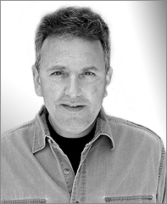
Thomas G. Miller, Supervising Editor

THOMAS G. MILLER has worked on documentaries and in public television for the past fifteen years. He associate produced the Sundance award-winning film LICENSED TO KILL (POV-PBS), and co-produced and edited FENDER PHILOSOPHERS (PBS) and the feature documentary CAMP OUT (MTV-Logo). He has also edited the feature documentary films, ROCK THE BOAT (HBO), GOOD KURDS, BAD KURDS, (Independent Lens-PBS), and HOME OF THE BRAVE (Sundance, Court TV). He just completed directing, producing, co-writing and co-editing the feature documentary, ONE BAD CAT: The Reverend Albert Wagner Story. Other credits include producing television films for Discovery, and WNET’s series on disabilities, PEOPLE IN MOTION.

Tom is on the board of the International Documentary Association, a member of the Academy of Television Arts & Sciences and the Writers Guild, and has been teaching documentary filmmaking and editing at the USC School of Cinematic Arts for six years. He is also a pediatrician and has served as medical consultant for Sesame Street and other film and television series. He graduated with a BS degree in zoology from The University of Michigan, an MD from the Medical College of Ohio and an MFA from the USC School of Cinematic Arts.

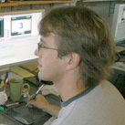
Marcus Taylor, Editor

Marcus has edited at DreamWorks Studios on big budget feature films including FLUSHED AWAY, MADAGASCAR, SHARK TALE, SINBAD, THE PRINCE OF EGYPT, AN AMERICAN TAIL: FIEVEL GOES WEST. A native of the U.K., Marcus first started working on television documentaries and dramas in Manchester. After working on a number of BBC, Granada TV and independent programs, he moved to Cosgrove Hall productions to work on various award-winning TV animation series such as DANGERMOUSE, COUNT DUCKULA and THE RELUCTANT DRAGON, which won the BAFTA TV Award for Best Short Animated Film. Marcus' association with Steven Spielberg's Amblimation company and DreamWorks has lasted over 17 years. During his time in London, he moved into features and saw the change from film to AVID-based editing. Embracing this new direction, Marcus was involved in the AVID USERS GROUP in London and wrote articles for their trade publication. His latest credits include SHREK: THE HALLS (a Christmas TV special), Jerry Seinfeld's BEE MOVIE and the short film FIRST FLIGHT. He was lead editor on FIRST FLIGHT (produced by DreamWorks Animation), which won the Montgomery Prize - Certificate of Excellence at Chicago’s International Children's Film Festival and was nominated for first prize at the Montreal World Film Festival. He also has worked with Simon Wells, the director of THE TIME MACHINE, on creating storyboard animatics for that movie. Marcus edited DUCK, the live action feature film starring Philip Baker Hall (ZODIAC/BRUCE ALMIGHTY/MAGNOLIA) that opened in August 2007. DUCK won the Audience Award at Cinequest and won Best Foreign Dramatic Feature at the European Independent Film festival and has been shown in numerous festivals around the world.

Kubilay Üner, Composer

Munich-born, Los Angeles-based composer Kubilay “Kubi” Üner has bounced around the planet and through every musical genre, which explains a thing or two about his individual approach to music. With numerous feature film scores, TV pilots and concert music works to his credit, Kubi is as comfortable in the concert hall as he is on the dubbing stage. "Whether the music is part of a film or stands on its own, my goal is to deliver an intense experience, one that completely immerses and transforms the listener. I believe a good piece of music should take you on a journey." This idea was at the core of FILM2MUSIC, an international competition for which Kubi invited filmmakers the world over to create a film to a track from his CD, CINEMATIC. 94 films were submitted, and the winners and highlights were screened at the 2007 Sundance Film festival. In addition to writing for concert, theatre and film, Kubi has acted as a record producer and arranger for a multitude of artists, from soul legend Bobby Womack to Mexican-American chanteuse Perla Batalla. Active in the Los Angeles contemporary music scene, he has run a series of composer salons since 2001, with such diverse presenters as Randy Newman to Mort Subotnick, Chris Young, Anne LeBaron and William Kraft, among many others. These stylistically diverse salons are yet another expression of Kubi's conviction that "good music can only happen when you mix things up." Kubi studied composition with Johannes Fritsch and Klarenz Barlow at the State Academy of Music in Cologne, Germany; with Luigi Nono at the Centre Acanthes workshops in France; and with Mort Subotnick, Fredric Rzewski and James Newton at CalArts. He earned his master's degree in 1991, and now works as a freelance composer and producer in Los Angeles.

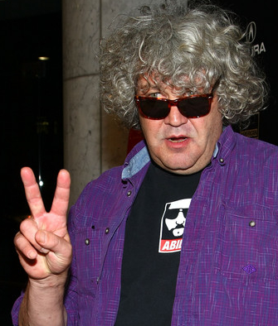
Jeff Dowd, Marketing and Sales Consultant

Jeff Dowd and Associates, a Los Angeles-based writer/producer, producer’s representative. Mr. Dowd was a producer of ZEBRAHEAD which Oliver Stone executive produced. ZEBRAHEAD won the Filmmakers Award at the Sundance Film Festival and was released by Sony Pictures. He co-executive produced FERNGULLY...THE LAST RAINFOREST, the animated feature starring Robin Williams, Tim Curry and Christian Slater. It was released by Twentieth Century Fox and won the Environmental Media Association (EMA) Best Picture award. Mr. Dowd has consulted on the marketing or been a producer's representative of such diverse films as CHARIOTS OF FIRE, GANDHI, DESPERATELY SEEKING SUSAN, THE BLAIR WITCH PROJECT and KISSING JESSICA STEIN. Jeff Dowd is the real life “The Dude” played by Jeff Bridges from the BIG LEBOWSKI by the Coen Brothers.

CONTACT

Attorneys
Evan Krauss and Jonathan Gray
Gray Krauss Des Rochers
207 West 25th Street, Suite 600
New York, NY 10001
212 966-6700
http://www.indyfilmlaw.com/

Website and online marketing
Hillary Carlip
Fly HC
hillary@flyhc.com
http://www.flyhcmultimedia.com/

Director/Producer
Hilari Scarl
Worldplay, Inc.
1320 N. Martel Avenue #6
Los Angeles, CA 90046
Hilari@worldplayinc.com
310 467-5054
www.seewhatimsayingmovie.com

CAST and CREDITS (partial list – full credits upon request)

A Worldplay, Inc. Production

Produced & Directed by Hilari Scarl

Edited by
Marcus Taylor
Morgan R. Stiff

Director of Photography
Jeff Gatesman

Original Music by
Kubilay Üner

Supervising Editor
Thomas G. Miller

Supervising Sound Editor and Re-Recording Mixer
Joe Milner

ASL Translation Master
James Foster

Music Supervisor
Mason Cooper

Featuring
Robert DeMayo
TL Forsberg
Bob Hiltermann
CJ Jones

Additional Editors
Nels Bangerter
Peter Lynch

Dalan Musson – writer consultant
Lisa Leeman – story consultant
Fernanda Ross – story consultant

Interpreters
James Foster
Derryn Grey

FAN MAIL

IT MADE ME CRY!!!! OH, I CAN'T WAIT FOR YOU TO COME TO A TOWN NEAR ME SO I CAN SEE THIS F-A-N-T-A-S-T-I-C MOVIE!!!!!
PLEASE, PLEASE, PLEASE BRING THIS MOVIE TO US!
--------------

I am hard of hearing. Learning about this film and seeing the trailer brought tears to my eyes. I don't know. Validation I guess? Thank you.
------------
HOLY COW, was I blown away. I am just so glad that someone (YOU!) took such a huge chance in making this movie because even aside from the intriguing subject matter, it is simply this-- A GREAT FILM.
Thank you (and I really mean it-- Thank You),
Crystal
-------------
Brandon saw the movie last week with CSUN and insisted that his Mom made the 13-hour round trip to see the film. When asked by his Mom to rate the movie out of 10 - he said 20!!! A true WOW moment!
-------------
Thank You again for making this documentary. It was awesome and I am just glad that I saw it.
It changed my life.
-------------
I am a hearing person that is learning asl. I saw the movie last night for my Deaf Event. This movie moved me like no other movie has. Thank-you
Jolene
-----------
I attended the sneak peek at ASU and was very touched by your work. I feel that it really opened my eyes to the Deaf Community and helped me understand a lot more than I ever could have in a class room setting.
----------
You have moved me, inspired me, motivated me, educated me.
I NEED to see this film many times more.
-----------
I'll admit it, I had tears in me eyes as I watched your movie. It touched me in a way that I could have never imagined. I am sure I have crossed paths with at least a few hearing impaired individuals in my life, but I personally do not know anyone that is deaf. After watching your film, I wish I did. I've been shown a completely other view of the world, a beautiful view, and my heart and mind have opened to it. I want to see this movie again!
Sincerely,
Karina (Los Angeles)

www.seewhatimsayingmovie.com

